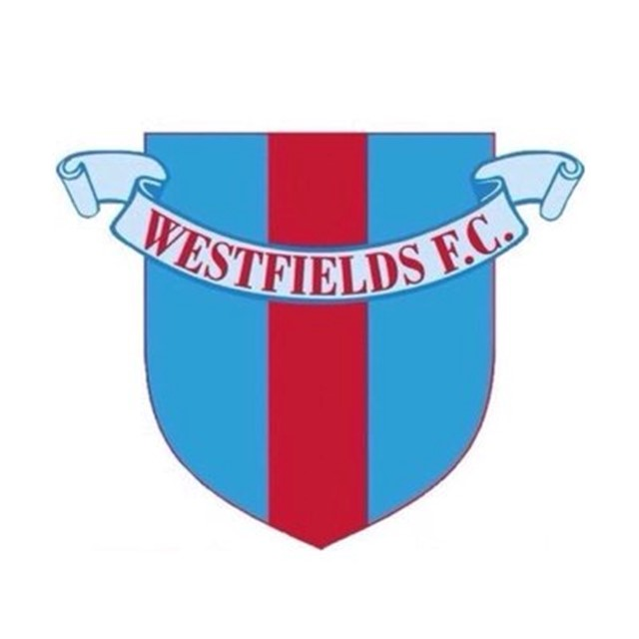
Westfields Football Club

Risk assessment – Covid-19 – Return to Playing Football

Westfields Football Club has a duty of care to protect the safety and welfare of its staff, volunteers, customers and contractors at all times and must ensure the implementation of safe and effective social distancing and hygiene measures in line with government advice to limit the potential for Covid-19 infection.

If at any time the club believes such safety and welfare is potentially compromised it reserves the right to consider cancellation or amendment of any activity while measures are reviewed. All activities must be carried out in accordance with current Government Covid-19 guidance.
-

Date of assessment: updated 11th December 2020

What are the hazards? | Who might be harmed? | Controls Required? | Additional Controls?
Spread of Covid-19 | Players, Coaches, Match and Club Officials  Parents/Guardians,  Contractors, Volunteers, Spectators, Bar staff, Cleaners, Grounds staff.  Players, Coaches,  Parents/Guardians, Match and Club Officials  Contractors, Volunteers, Spectators, Bar staff, Cleaners, Grounds staff, spectators. | ALL CLUB OFFICIALS / MANAGERS, COACHES, PLAYERS AND STAFF MUST READ THE FA GUIDANCE DOCUMENTS TO BE FAMILIAR WITH THE FA REQUIREMENTS.  PREVENTING THE SPREAD OF COVID-19:  All visitors to the Club will be asked to sanitise their hands prior to entering the ground.  Provide hand sanitisers at prominent traffic areas throughout the facility so that users can sanitise their hands regularly.  On match days and training sessions a sanitising station will be placed at entrance to ground and at entrance to the clubhouse – if the Clubhouse is open. Wall mounted sanitisers units will be placed by toilets and changing rooms.  Ensure that all hand sanitiser stations are in good working order.  Display hygiene standards promotional signage at entrance to the ground on match days.  Implement a one-way system through the Club and display one-way directional signage to assist with travel around the club.  Direct people to bring their own labelled water bottle to training sessions and not to share any drinks bottles.  Provide first aiders with appropriate PPE.  Goalkeepers must wear their own gloves and not share them with others.  Anyone showing symptoms of Covid-19 to be refused entry.  A record of all people who enter the ground will be maintained to assist with the Track and Trace system. All coaches will be required to maintain a record of all attendees at all training sessions and matches.  Minimise the use of cash handling by encouraging payment via debit card. Cash handlers will be required to sanitise hands regularly in the event that that do handle cash.  Sneeze screens will be installed in the bar and serving hatch area to protect staff.  Match day paperwork should be kept to a minimum. The transfer of team sheets via a paper system can be done only if an electronic copy cannot be used.  Payments to Match Officials will be completed via BACS payments to avoid cash handling, when possible.  Travel to training and matches must be via car or minibus where walking or cycling are not possible. Anyone sharing a journey must wear face masks and ensure that the vehicle is well ventilated with windows open. Passengers must wash their hands immediately on arrival at their destination.  Access to toilets will be restricted to one person in the toilet area.  The Clubhouse will be closed.  MAINTAINING HYGIENE AND CLEANLINESS:  Club cleaners to be provided with appropriate PPE for conducting cleaning tasks.  Cleaning of identified touch points throughout the facility will be performed by cleaning staff at regular intervals.  Equipment is to be set out before training and moved as infrequently as possible.  Where equipment is moved, it must be cleaned thoroughly prior to secondary use. Balls must be sanitised after every session. A 4 ball system for match balls is to be used. The 3 balls not in use must be sanitised prior to being used on the field of play.  When the club house is permitted to be used all tables, furniture and touch points must be cleaned with a fogging machine prior to use and wiped down with sanitiser solution at regular intervals.  All drinks will be served in disposable cups / glasses and disposed of by the user after use.  Players will be to attend training sessions in their kit ready to play.  Players may use the changing rooms with a maximum of 6 people at one time. No more than 2 people per time to use the showers.  Time in changing rooms should be kept to under 15 minutes.  MAINTAINING SOCIAL DISTANCING AND AVOIDING CONGESTION:  Training programmes will be reviewed and adapted to minimise the risk of congestion. Teams will be required to use separate areas of the grounds in order to minimise contact.  Where travel by car cannot be avoided people car sharing must be from the same household or bubble. Face masks must be worn.  The grassed areas of the car park are to be used to avoid parking congestion.  Regulate the entry to the facility in line with FA Guidance to avoid overcrowding (to include clear instructions to parents/guardians in terms of drop-off/pick-up.  The clubhouse will not be open.  All players need to be informed of the need to adhere to social distancing guidelines including issue of the FA Code of Behaviour requirements.  Spectator numbers will be limited in accordance with FA Guidance. This is currently 300.  Spectators will be asked to maintain a social distance of 2 metres. Those from the same bubble or family group can congregate in groups of 6. Stewards to ensure that this is adhered to.  Prior to any match a safety briefing must be given to both sets of players before the game. This will cover their responsibilities in accordance with the FA code of conduct.  Additional seating will be made available in the technical areas so that substitutes and coaching staff can maintain social distancing.  Seating in the grandstand will be restricted to account for social distancing. Spectators will be permitted to sit together if they are from the same household.  Spectators that are not from the same household will be asked to sit a minimum of 2 metres away from any other spectator.  SUPPORTING NHS TEST AND TRACE  QR Code posters for NHS track and Trace will be placed at entrance to the ground. All visitors to the ground will be asked to scan the poster on entry. Visitors without the app will be required to provide their contact details before being admitted through the turnstile.  The Head of Admin or Covid Officer will request a main contact for each team that visits the Club. The actions to be taken will include:  - Coaches to maintain a register of all players and coaches that attend training sessions  - A record will be kept of all opposition players, officials and supporters that attend from visiting teams. | A summary of the Clubs approach towards Covid-19 measures will be published on the website and displayed within the Club.  This Risk Assessment will be distributed to all officials, managers, coaches, players and staff.  A summary of the key control measures implemented from this risk assessment will be forwarded to opposition teams ahead of their visit. Andy Morris to do this ahead of each game for Hellenic League games.  All other team managers are to make opposition clubs aware of our risk assessment in advance of their attendance to Allpay Park for games.  Communicate via website and signage around the facility  Perform check of sanitiser stock levels and top up if necessary  Hand sanitisers will be placed in the changing rooms and on bar tables.  A temperature check to be taken for everyone entering the ground. Anyone with a temperature above the reading of 37.8 or higher will not be allowed entry to the ground.

